DPU Update Script Design doc 1.1
Contents
1. Description 1
2. Design 1
2.1. Architect 1
2.2. Command parameters 2
2.3. Normal output 2
2.4. Error List 3
2.5. Log and Debug 4
2.6. Limitations 4
3. Workflow 5
3.1. BMC firmware update 5
3.2. CEC Firmware update 5
3.3. ATF/UEFI firmware update 6
3.4. BUNDLE firmware update 8

Description
DPU update script (OobUpdate.sh) is a program for updating various component firmware of Bluefield DPU, like BMC, CEC and BIOS(ATF&UEFI). It works from out of band, using Redfish API exposed by BMC of DPU. The script can work from any controller host (Linux), which has available connection to the DPU BMC system.

This design document corresponds to version 25.04-2.1 of the script.

Design

Architect
The DPU Update Script works as following chart:

ARM OS
BMC
ATF/UEFI
DPU
Redfish(Restful) API
DPU Update
Script
Controller Host
- DPU Update Script can run from any machine (Controller Host), which can establish connection to DPU BMC’s OOB interface.
- The script connects and manages the DPU through Redfish (Restful) API exposed by DPU BMC.
- The script is mainly implemented by Python3.

Command parameters
OobUpdate.py [-h] [-U <username>] [-P <password>]
[-S <ssh_username>] [-K <ssh_password>] [-F <firmware_file>]
[-T <module>] [--with-config] [-H <bmc_ip>] [-C]
[-o <output_log_file>] [-p <bmc_port>] [--config <config_file>]
[-s <oem_fru>] [-v] [--skip_same_version] [-d]
[-L <path>] [--task-id <task_id>] [--lfwp]

options:
-h, --help show this help message and exit
-U <username> Username of BMC
-P <password> Password of BMC
-S <ssh_username> Username of BMC SSH access
-K <ssh_password> SSH password of BMC
-F <firmware_file> Firmware file path (absolute/relative)
-T <module> The module to be updated: BMC|CEC|BIOS|FRU|CONFIG|BUNDLE
--with-config Update the configuration image file during the BUNDLE update process.
-H <bmc_ip> IP/Host of BMC
-C Reset to factory configuration (Only used for BMC|BIOS)
-o <output_log_file>, --output <output_log_file> Output log file
-p <bmc_port>, --port <bmc_port> Port of BMC (443 by default).
--config <config_file> Configuration file
-s <oem_fru> FRU data in the format "Section:Key=Value"
-v, --version Show the version of this scripts
--skip_same_version Do not upgrade, if upgrade version is the same as current running version
-d, --debug Show more debug info
-L <path> Linux path to save the cfg file
--task-id <task_id> Unique identifier for the task
--lfwp Live Firmware Update patch. Works only with BUNDLE module.

Normal output
In normal successful case, the script will only have a few messages show in standard output. Like following:
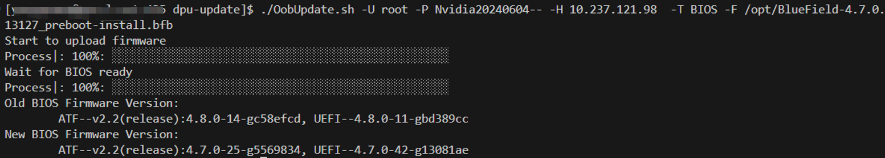

Error List
While this script is running, errors may be encountered. Related error message will show in error output.

Following is error list the script may encounter:
Index | Error Name | Error Message
1 | ARG_FOR_UPDATE_NOT_GIVEN | BMC IP/Username/Password, Firmware file path and Module are needed to do firmware update
2 | FILE_NOT_ACCESSIBLE | File is not accessible
3 | FW_FILE_NOT_MATCH_MODULE | Given firmware file is NOT for the Module to update
4 | BMC_CONNECTION_FAIL | Failed to establish connection to BMC. Please check the BMC IP and port
5 | BMC_CONNECTION_RESET | Connection to BMC being reset by remove
6 | ACCOUNT_LOCKED | Account has been locked
7 | INVALID_USERNAME_OR_PASSWORD | Invalid username or password
8 | ANOTHER_UPDATE_IS_IN_PROGRESS | Another update is in progress; Please try to update the firmware later
9 | UNSUPPORTED_MODULE | Unsupported updating module
10 | BAD_RESPONSE_FORMAT | Bad response format
11 | INVALID_STATUS_CODE | Invalid response status code
12 | FAILED_TO_GET_LOCAL_KEY | Failed to get local SSH Key
13 | FAILED_TO_ENABLE_BMC_RSHIM | Failed to enable BMC rshim; Please make sure rshim on Host side is disabled
14 | NOT_SUPPORT_CEC_RESTART | CEC restart redfish API is not supported in this version; Please use power cycle of the whole system instead
15 | BMC_BACKGROUND_BUSY | BMC is busy on background operation; Please try to update the firmware later
16 | PUBLIC_KEY_NOT_EXCHANGED | Public key was not exchanged with BMC successfully
17 | BIOS_FACTORY_RESET_FAIL

Log and Debug
There are some additional logs recording details of each restful request & response. Those logs can be used in debugging issues.
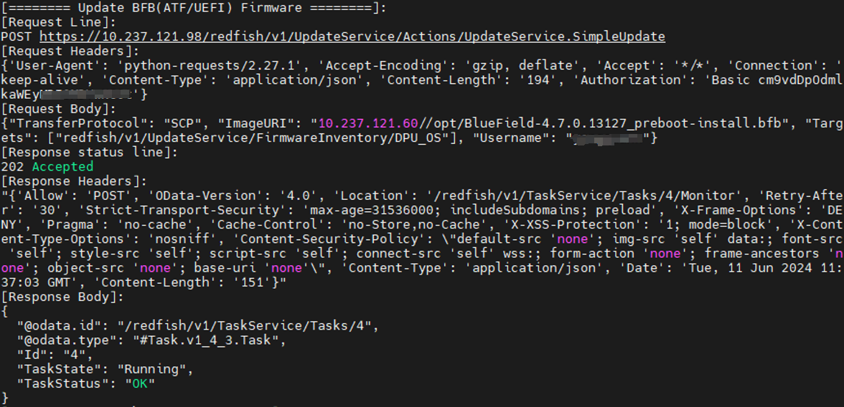
- If command has argument -d (--debug) , those additional logs will be shown in output
- If command has argument -o (--output_log_file), those additional logs will be written into the log file.

Limitations
- The script can only run on Linux host, with python3 installed
- The rshim on Host side (in which DPU plugged) need to be disabled, if want to update BIOS firmware of DPU or use BUNDLE module
- The target DPU BMC version should be >= 24.04
  - Some redfish API may not be supported for earlier BMC versions.
  - That also means the script can only support >= Bluefield 3
  - The DPU BMC needs to be upgraded to >= 24.04 by other means, before using this script.
- The target DPU BMC version should be >= 25.04
  - To support Live Firmware Patch (LFWP)
- The default user/password of DPU BMC should be updated in advance.
- For one DPU system, there can only be one update task at the one time. The later coming task will get “Another update is in progress" error.
- In NIC mode, the BMC's Redfish chassis schema contains only limited information about BlueField (like versions of different components). This is because, in this mode, the OS is not available to supply the necessary information to the BMC.

Workflow

BMC firmware update
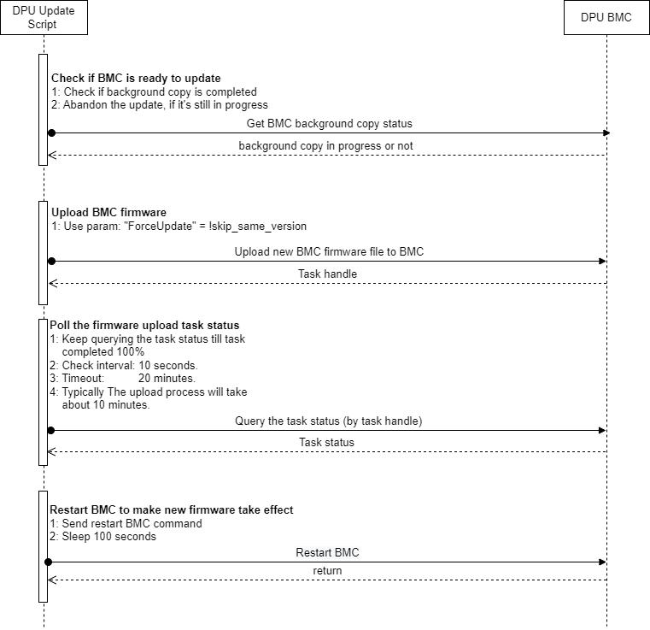

CEC Firmware update
The CEC firmware update workflow is similar as BMC firmware update. Except for following:
- The upload process will take less than 4 minutes
- Will check task status every 2 seconds
- Will wait 120 seconds, after CEC restart.

ATF/UEFI firmware update

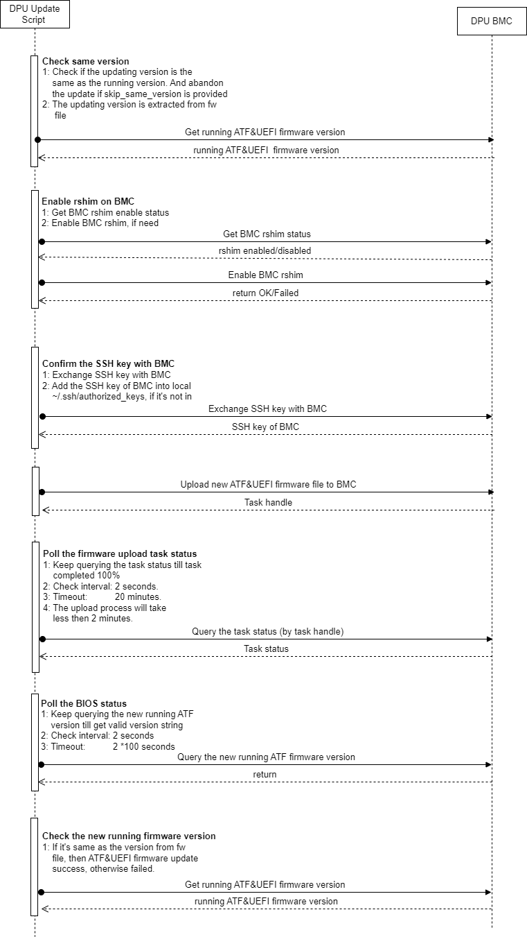

BUNDLE firmware update
The bf-fwbundle BFB update process uses the Redfish SimpleUpdate API to transfer firmware bundles to the BMC. Key stages:
- OobUpdate validates arguments and confirms BMC SSH credentials are provided.
- Creates bf.cfg configuration file and appends to the original bf-fwbundle BFB:
BMC_USER=<Redfish_username>
BMC_PASSWORD=<Redfish_password>
BMC_SSH_USER=<SSH_username>
BMC_SSH_PASSWORD=<SSH_password>
BMC_REBOOT="yes"
CEC_REBOOT="yes"

- Checks for config-image.bfb presence in the bf-fwbundle to determine if ResetBios is required post-update.
Note: config-image.bfb will not be updated by default. To enable config-image.bfb update use ‘--with-config’ parameter.
- Parses the info json file coming with the bf-fwbundle to extract component versions from the bundle.
- BFB update sequence:
  - Enable RSHIM on the BMC via Redfish API
  - Initiates SimpleUpdate task to transfer BFB via RSHIM
    - Simple Update sends the bf-fwbundle BFB to the DPU via RSHIM interface and finishes once the BFB is fully uploaded. During this time the DPU resets and starts running the BFB installation environment.
    - BFB installation environment is running on the DPU. Update sequence:
      - ATF/UEFI firmware capsule
      - BMC Firmware (if not the same)
      - BMC restart to apply the new version (disconnects BMC console)
      - CEC Firmware (if not the same)
      - CEC restart to apply the new version
      - DPU Golden Image
      - NIC Firmware Golden Image (if exists)
      - config-image.bfb
      - NIC Firmware
      - NIC Firmware reset using mlxfwreset to apply the new version (if supported in current state)
      - Reset DPU to finish the installation
      - New ATF/UEFI activated
      - Load DPU OS
- Waits for the DPU readiness
- DPU reset to apply the new configuration from the config-image.bfb
- Collects new versions of all the running components
- Generates version comparison table

